DO’S AND DON’T FOR CONSUMABLE ALCOHOL
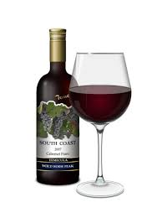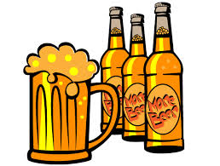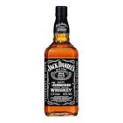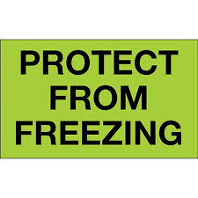
LME DIRECT:
DO: OK FOR UP TO 6 STANDARD SKID POSITIONS
DO: OK UP TO 672 CUBE
MAXIMUM LIABILITY: $2.00 PER POUND
TRNET MOVES
LME PICK UP: DO NOT PICK UP. CONTACT YOUR DISPATCHER.
LME RECEIVES IT: WE CAN DELIVER IT FROM THE PARTNER BUT WILL HAVE ZERO LIABILITY ON ANY CLAIM. PLEASE LET CLAIMS KNOW WHEN YOU RECEIVE ANY ALCOHOL IN ERROR !!!!
It depends on the alcohol content, but most wine will freeze at about 15 to 20 degrees F, and it would need to stay at that temperature for a while before it freezes solidly. Alcohol's freezing point is lower than water, but as the water content of the wine begins to freeze, it will begin to expand, and this will put a lot of pressure on the cork, which might begin to be pushed out, and on the bottle, which might crack. Don't freeze your wine bottles!
Most beers freeze at 27 degrees Fahrenheit or about -2 degrees Celsius. Light beers freeze at a slightly higher temperature of 31 degrees Fahrenheit or -0.5 degrees Celsius
Contrarily, higher proof means a lower (colder) freezing point. So, 84 proof liquid would freeze at -34°C but 24 proof at -6 °. Whisky like Jack Daniels is about 80 Proof (vol 40%), so it would have a freezing point of about -26 °C.

